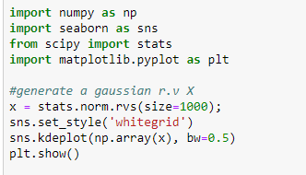

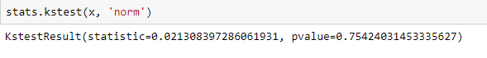

Here First we are testing for a normal distribution against a normal distribution.

Here we get output as **statistic** which is **Dn,m** and **pvalue** which is the value we obtained by converting ks test into hypothesis,

Here pvalue is 0.75.. which > 0.05 and we know if

Pvalue < 0.05 then reject null hypothesis (which is both are same dist), otherwise we accept hypothesis hence both are same dist.

2 ) Now we check uniform dist against normal dist.

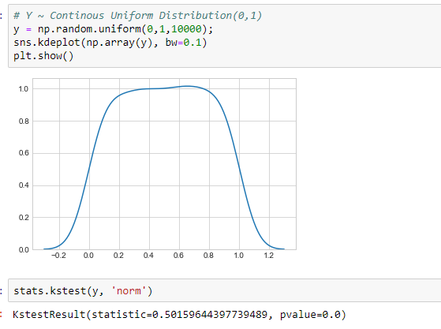

Since pvalue = 0 which is < 0.05, hence we reject null hypothesis that both are same dist.